Candidate Number

Please stick the barcode label here.

Marker’s

Use Only
 |  | Marker No.
Question No. |  | Marks
1
2
3
4
5
6
7
8
9
10
11
12
13
14
Total

ARISTO EDUCATIONAL PRESS

HONG KONG DIPLOMA OF SECONDARY EDUCATION EXAMINATION

ECONOMICS PAPER 2
(Mock Test 32)

Question-Answer Book

Time allowed: 2 hours 30 minutes
This paper must be answered in English

INSTRUCTIONS
- After the announcement of the start of the examination, you should first write your Candidate Number in the space provided on Page 1 and stick barcode labels in the spaces provided on Pages 1, 3, 5, 7, 9, 11, 13, 15, 17, 19, 21, 23 and 25.
- This paper consists of three sections, A, B and C. Answer ALL questions in sections A and B. Attempt any ONE question in section C.
- Write your answers in the space provided in this Question-Answer Book. Do not write in the margins. Answers written in the margins will not be marked.
- Supplementary answer sheets will be supplied on request. Write your candidate number, mark the question number box and stick a barcode label on each sheet, and fasten them with string INSIDE this book.
- No extra time will be given to candidates for sticking on the barcode labels or filling in the question number boxes after the ‘Time is up’ announcement.

Section A (44 marks)

1. Kylie works in a fast food shop. She is considering whether to go to work or to visit a food fair on Saturday. Due to the large number of people visiting the food fair, people need to queue up for admission.

Explain how Kylie’s opportunity cost of visiting the food fair will change if

(a) the fast food shop raises the hourly rate on weekends by $20. (2 marks)

(b) fewer people visit the food fair due to bad weather. (3 marks)

2. (a) To which type of production does fishing belong? Explain. (2 marks)

(b) Fishing generally involves people with different skill sets, including captains, crew and workers handling fish. What economic principle is illustrated by the above phenomenon? Suggest THREE reasons why the application of this principle can increase labour productivity. (4 marks)

(c) State ONE example of variable cost incurred in fishing. Explain your answer. (2 marks)

3. Refer to the following table.

 | Per capita real GDP | Gini coefficient based on original household income | Gini coefficient based on post-tax household income
Country A | $50,000 | 0.52 | 0.44
Country B | $45,000 | 0.48 | 0.46

(a) Give TWO reasons why the standard of living of people in Country A is not necessarily higher than that of people in Country B. (2 marks)

(b) Explain which country’s tax policies are more effective in reducing income inequality. (2 marks)

Please stick the barcode label here.

4. In June 2023, the Kowloon Motor Bus Co. (1933) Ltd. increased the fares of its bus services.

Explain under what condition the fare revenue of the company will decrease. (5 marks)

5. The table below shows the changes in the GDP deflator of a country.

Year | Year-on-year growth rate of GDP deflator
2020 | +2.6%
2021 | +1.9%
2022 | +1.1%

(a) Explain whether inflation occurred in the country during the above period. (2 marks)

(b) ‘The real wage of workers in the country must have decreased during the above period.’ Do you agree? Explain your answer. (3 marks)

Please stick the barcode label here.
6. Lithium is a metal that is used to make batteries for electric vehicles. Suppose the price of lithium in
Country A decreases sharply.

(a) (i) With the aid of a diagram, explain how a sharp decrease in the price of lithium in Country A will affect the total social surplus in the market of electric vehicle batteries in Country A. (4 marks)

(ii) Explain whether the above change in the price of lithium would improve or worsen economic efficiency. (2 marks)

(b) Due to the increasing demand for electric vehicles in Country A, more electric vehicle manufacturers decide to open factories in Country A. Explain which function of price is illustrated in this case.
(2 marks)

7. The table below shows the items of the balance of payments of Country A in 2022.

 | Debit ($ million) | Credit ($ million)
Domestic exports of goods |  | 50
Re-exports of goods |  | 15
Imports of goods | 20
Exports of services |  | 45
Imports of services | 48
Capital inflow |  | 30
Capital outflow | 52
Reserves assets | 20
Total | 140 | 140

(a) Calculate the current account balance of Country A. (1 mark)

(b) Explain whether the balance of payments of Country A was in deficit or surplus in 2022. (2 marks)

Please stick the barcode label here.
8. The table below shows the production and consumption data of Country A. The country only produces and consumes rice and clothing.

 | Rice (units) |  | Clothing (units)
Total production without trade | 20 | AND | 40
Total production with specialisation | 50 | AND | 0
Total consumption with trade | 30 | AND | 50

(a) Calculate the opportunity cost of producing 1 unit of clothing for Country A. (2 marks)

(b) Find the terms of trade for 1 unit of clothing. (2 marks)

(c) Country B is the only trading partner of Country A. Assume that the opportunity cost of producing
1 unit of clothing in Country B is 0.25 units of rice. The transportation cost of trading 1 unit of clothing is 0.1 units of rice, and the transportation cost is borne by the exporting country. Calculate the total gain from trade for Country B from exporting clothing. (2 marks)

END OF SECTION A

Section B (60 marks)

9. A football club was acquired by an oil company.

(a) Explain which type of expansion the above acquisition was. (2 marks)

(b) List TWO possible reasons why the oil company chose to acquire a football club instead of another oil company. (2 marks)

(c) In addition to the fixed weekly salary, some football players will also be paid bonuses according to the number of goals scored. From the viewpoint of football clubs, explain TWO advantages of using this wage payment method over time rate. (4 marks)

(d) Some TV stations buy the rights to broadcast football matches and broadcast the matches to the public for free. Explain whether the TV broadcasts of the matches are free goods. (2 marks)

(e) In reality, some football clubs are listed companies. State ONE advantage and ONE disadvantage of a football club being a listed company instead of a private limited company. (2 marks)

Please stick the barcode label here.

10. In June 2023, the South Korean government distributed a set of coupons for local accommodation and tour packages to boost domestic consumption.

(a) When people purchased accommodation for a price exceeding 50,000 Korean won in any region in South Korea, a coupon of 30,000 Korean won would be given.

Compared with directly distributing 30,000 Korean won to residents in cash, explain an advantage of the above arrangement for the economy of South Korea. (3 marks)

Suppose South Korea initially has a deflationary (output) gap.

(b) With the aid of a diagram, explain how the above action can help South Korea restore its aggregate output to the full-employment output level in the long run. (6 marks)

(c) WITHOUT using a diagram, explain why even without the help of the government, market forces can restore South Korea’s aggregate output to its full-employment output level in the long run. (4 marks)

Please stick the barcode label here.

0
D₀
S₀
Rent
Quantity
Figure 1: Leasing market for offices
Please stick the barcode label here.
11. With the advancement of communications technology, more and more companies are allowing their employees to work from home.

(a) An employee replies to customers’ emails from his home computer. Explain which factor of production the computer belongs to. (2 marks)

(b) A company decides to allow more employees to work from home in order to reduce the size of the office and save rental costs. Explain to what basic economic problem the company’s decision is related. (2 marks)

(c) As more companies allow their employees to work from home, the rents of commercial buildings decrease. However, the vacancy rate still increases. With the aid of Figure 1, explain the above phenomenon. (5 marks)

(d) Suppose some banks decide to hold more excess reserves as they are worried that the high vacancy rate of commercial buildings will affect the solvency of developers. Explain how this will affect the deposit creation ability of the banking system in the economy. (2 marks)

Please stick the barcode label here.
12. The labour force in Hong Kong has been declining and the government has introduced measures to alleviate the shortage of labour in many industries.

Source A: Hong Kong’s labour force by educational attainment
(Source: Census and Statistics Department, HKSAR Government)

Source B: Information about the government’s introduction of the labour importation schemes for the construction and transport sectors and the enhancement of the existing Supplementary Labour Scheme
Labour importation schemes for  construction and transport sectors | Enhancement of the existing  Supplementary Labour Scheme
- Subject to fulfilment of the specified parameters, the sector-specific labour importation schemes would allow employers in the construction and transport sectors to apply for quotas for importation of labour. The total quota for the two sector-specific labour importation schemes is 20,000, comprising 1,700 for the public light bus/coach trade.  - The wage levels of imported labour must be no lower than the median monthly wages of relevant posts in Hong Kong. | - Under the existing scheme, there are 26 job categories and unskilled/low-skilled posts for which labour importation is not allowed. The 26 job categories include waiter/waitress, cashier and junior cook. After the plan is enhanced, the above exclusion will be suspended for 2 years. The Supplementary Labour Scheme will be renamed as the Enhanced Supplementary Labour Scheme.
(Source: Various newspapers)

Source C: Information about the Enhanced Supplementary Labour Scheme
According to the scheme, employers with genuine difficulties in recruiting suitable staff locally may apply for importation of workers at technician level or below. The employer is required to enter into a Standard Employment Contract with the imported worker of which the maximum contract period is two years. After entry, the imported worker must remain under the direct employment of the same employer for the specified job and in the specific workplace(s) as stipulated in the Standard Employment Contract. Change of employer, post or job duties is not permitted. The imported worker is required to return to his/her place of origin on completion of his/her employment contract.

Source D: Some views on labour importation
  A restaurant owner | The labour scheme introduced by the government has made it easier for my restaurant to hire suitable staff.
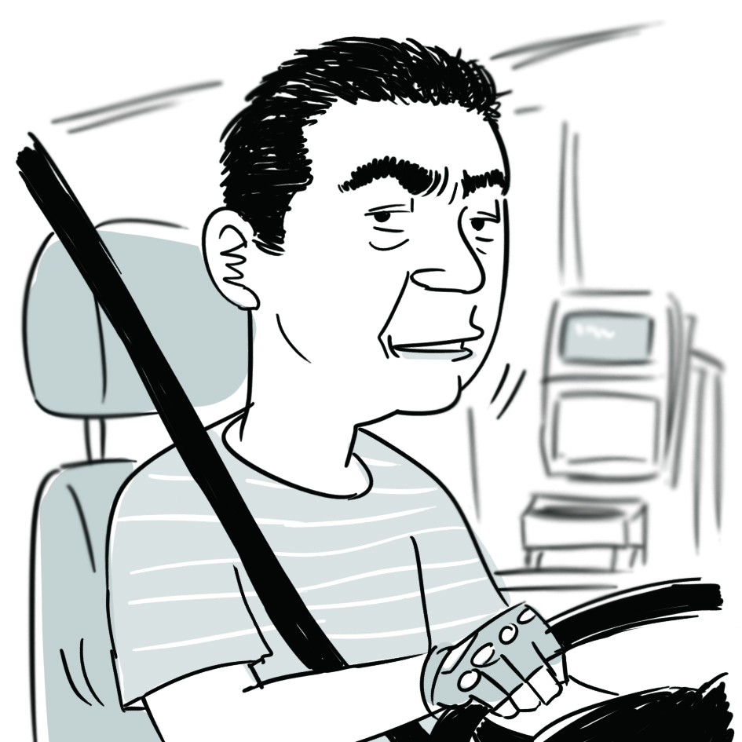  A minibus driver | Raising the minimum wage for minibus drivers is more likely to attract people to enter the industry than importing labour.

(a) Refer to Source A. Explain the effect of the change in labour force in Hong Kong from 2019 to 2022 on aggregate output in the long run. (2 marks)

(b) Refer to Source B. Explain how the labour importation schemes for construction and transport sectors will affect the mobility of overseas workers. (2 marks)

(c) Refer to Source C. Explain respectively, whether the income of overseas workers under the Enhanced Supplementary Labour Scheme would be included in the calculation of Hong Kong’s gross domestic product (GDP) and gross national income (GNI). (4 marks)

(d) Refer to Source B and the view of the restaurant owner in Source D. Explain how the labour importation scheme introduced by the government will affect the price elasticity of supply for catering service.
(2 marks)

For part (e), candidates are required to present their answer in essay form. Criteria for marking will include use of sources and economic theories, relevant content, logical presentation and clarity of expression.

(e) Suppose the government has two strategies to alleviate the problem of labour shortage.

Proposal I: Increasing the maximum amount of monthly allowance for trainees attending courses of the Employees Retraining Board (ERB)
Proposal II: Raising the minimum wage rate of specific sectors which have a labour shortage

With reference to the above sources and your own knowledge in Economics, discuss the effects of each strategy on the following variables in order to evaluate the two proposals.

- average labour productivity
- number of employed persons
- aggregate output
(14 marks)

Please stick the barcode label here.

END OF SECTION B

Please stick the barcode label here.
0
Quantity
Unit price
D
Figure 2
MC
Section C (16 marks) Answer any ONE question.

13. FoodCat is the only online food delivery platform in Country A. Figure 2 shows its demand curve and marginal cost curve.

(a) Suppose FoodCat adopts simple monopoly pricing. Indicate the profit-maximising output and price as Q1 and P1 respectively in Figure 2 and explain how FoodCat determines its profit-maximising output and price. (4 marks)

(b) Demand for food delivery services increases as more people work from home.

(i) How would an increase in demand for food delivery services affect FoodCat’s marginal revenue?
(1 mark)

(ii) Suppose FoodCat produces the same quantity after the increase in demand. With the aid of
Figure 2, explain whether economic efficiency will be affected. (3 marks)

(c) FoodCat offers a 20% discount to new customers. Explain whether this price arrangement constitutes price discrimination. (3 marks)

(d) Suppose there are other companies planning to join the food delivery market. FoodCat requires restaurants collaborating with it not to cooperate with other online food delivery platforms.

(i) Name the anti-competitive behaviour FoodCat is engaged in. List TWO possible motives for FoodCat to engage in such behaviour. (3 marks)

(ii) Which conduct rule of the Competition Ordinance might FoodCat have violated if the above case happened in Hong Kong? Explain. (2 marks)

Please stick the barcode label here.

Good Y (units)
Good X (units)
0
80
64
PPF_{B}
Figure 3
50
PPF_{A}

100
N
14. Figure 3 shows the production possibility frontier of Country A (PPF_{A}) and the production possibility frontier of Country B (PPF_{B}).

(a) Explain why the production possibility frontiers of both countries are straight lines but not concave to the origin. (1 mark)

(b) Explain which country has a comparative advantage in producing good X. (3 marks)

(c) Explain whether Country A can produce at point N. (2 marks)

(d) Suppose the terms of trade is 1X = 1Y. After Country A engages in trade, the quantity of good Y consumed is 50 units. In Figure 3, indicate the consumption possibility frontier (CPF_{A}), the consumption point (C_{T}), export volume and import volume of Country A after trade. (4 marks)

(e) Explain whether Country A can gain from trade. (2 marks)

(f) Explain TWO costs of economic growth that may result from opening up to trade. (4 marks)

Please stick the barcode label here.

Please stick the barcode label here.
END OF PAPER

